Validation of natural language requirements in RIM Monitoring and Operational business environment

Author:
Group : Menta R&D
Date: 27-7-2011

Abstract
In this paper, the validation of natural language requirement approach applied solution for solving problem and troubleshooting in RIM, NOC services is described. Next to a description of the use and goals of the method, a description of the eight main activities will be given. Furthermore, an example of the use of the described approach will be given.
Also a scientific context will be provided by covering overlapping, pre-existent and elaborated scientific research regarding the Menta article and its 0. 3 release of Menta R&D team.

Introduction

Description of use
That is an applied formal methods in the context of Lexical parsing of requirement engineering, incident – problem solving, and its troubleshooting can be defined as methods that are relatively cheap compared to the manual requirement – incident- problem engineering as a whole (many human resources involved in that process). The formal methods as such are not meant for creating (informal) requirements documents into formal documents, they are rather used to gradually validate requirements - incidents (obvious and implicit), explore essence of the matter of a requirements – incident document (problem-incident ticket, problem – incident report, analysis report and any). The goal of this approach is to have a usable low-cost, automated analysis – problem solving – resolution mechanism of natural language requirements.

Main activities
The method defines a total of eight steps to perform the formal requirements validations.
The first three steps are the set-up steps.
The first step is to define a style, a structure and an English language specific domain vocabulary for the specific document which contains the requirements (Requirement Document, Problem – Incident document/ticket). The second step is to select the core parts (merit) of the document which the method should check. As described, the method is applicable on general linguistic and specific IT technical domain parts) of a document that are of interest. The third step is to look at which properties of the parts are satisfied for established accepting criteria’s or have missing some parts, require additional elucidation of the rule , of the text that have been selected in the second step, will be checked with which models approach.
All steps until eight are the production steps according SLA OLA procedures and project agreements, and can be iterated on at any stage. It should be noted that all those steps, are completely automatic.
Step four is the pre-processing step where the format, structure and ascertainment of all details, including project-domain specific, missing details (detected and added from KB) are translated to a canonical form so it can be used for further automatic processing.
Step five consists of the final parsing the natural language text into semantic content.
Step six is the step where the models that were chosen in step three are built (provided generated solution).
Step seven checks if the models and output result successfully check the properties of the content and sufficient for final acceptance.
And finally step eight, which is an ambitious step, consists of evaluating the findings and checking and correcting the requirement specification for incident fixing and delivering final report for incident realization by system itself or manually by assigned specialists.

Example of method
For describing and elaborating the steps described in the main activities section a both, non-existent, (impartial, inconsistent, and implicit) or decent on natural language requirements document for describing the requirements of incident, problem is used. This requirements document (trouble ticket, problem-incident report) can be used by a IS Monitoring, Operational team in order to check on fly and automate in accordance with SLA timeframe whether the all incoming incidents – reports IS team received via the applied system (sources) has met its requirements and solved.
In the first step, one defines the style, structure and English language specific domain vocabulary for the specific document which contains the requirements of the incoming document (Requirement Document, Problem – Incident ticket document). The document was written in a consistent style and structure, has a good structural quality and was written in English.
In the second step is determined what properties are to check and what possible needed for clarification, by applying to domain-project specific KB. As the requirements - incident document contains lots of technical details that cannot be checked in real time by the Monitoring operator, all properties should be externally observable and marked (sufficient or not) were selected.
In the third step, Menta select the models on the properties will be checked, created requests to KB for correction and for missing objectives; in this case it will use the Circe Menta AI environment to provide automated analysis of the incident requirements. The environment allows the extraction of models from the incoming incident requirements, their validation and the collection of technical -domain data about the requirements document, the system described in it and about the requirements writing process itself.
In step four the document will be pre-processed, parsed, analyzed for sufficiency and ascertainment of all details, including project-domain specific, missing parts and ready to be translated to a canonical form so it can be used for further automatic processing (incident, change request realization mechanism ).
Step five consists of the parsing of the natural language text. The KB model from step three required a domain-specific term document (format, structure, content). This document -information was taken from the IS project SMDB-KB’s and covered all domain specific terms used in the incident-problem requirements document.
In step six, the building of the models was automatically done using the Menta AI Circe environment.
In step seven the properties that were selected in step two where finally checked. Each property was analyzed by the use of specialized validators (supported in the Menta Circe environment) and consisted of a logical model for incident-problem troubleshooting resolution, mainly focusing on consistency and feasibility by Menta itself. In step eight, the result such incident –problem either fixed and closed tickets or not fixed tickets send by system to operational expert. On regular base not fixed tikets checked by an IS incident – problem knowledgeable requirement specialist, mainly for consistency errors to improve Menta performance .

Menta Process-Realization and validation diagram
In résumé of explaining the method, figure 1 shows a process-realization and validation diagram of the method.
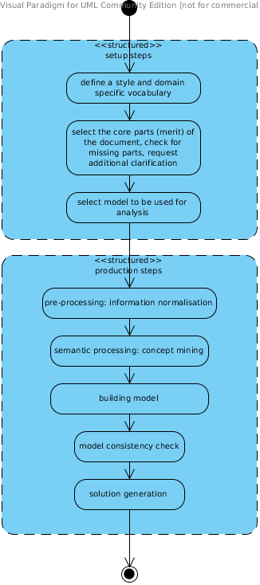

Description of activities
Activity | Sub-activity | Description
Prepare validation | Pre process incoming document |  | The activity where the format, structure, lexical and typographical details are translated to a canonical form so it can be used for further automatic processing.
 | Define style |  | Defining the style of the document
 | Define structure |  | Define the document structure
 | Define language clarity |  | Defining in which manner of natural language the document was written subject to specific IT domain vocabulary
Parse-NL requirements |  |  | Parsing the natural language text into semantical content
Create models | Define models |  | Defining which models the properties are going to be checked on. In this case defining can just be checked the pre existing KB model or elaborating with variety of sources (internet, SMDB,s ) on new models in case if some properties can’t be checked with current.
 | Build models |  | Building of the models with regards to the parsed document, on the basis of the defined models in the previous step.
Process properties | Define properties |  | Which properties of a certain document or system described in a document are ‘interesting for incident -problem resolution’ depends on the particular context of the analysis. As it is common with project requirements and its KB formal project methods, partial validation is usually acceptable at this.
 | Check properties |  | Checks if the models successfully check the all properties of the content to satisfy necessary requirements for farther incident-problem resolution.
Evaluate findings |  |  | Evaluating ﬁndings and revising the requirements speciﬁcation for incident - problem solving accordingly. It is particularly important that the validation checks provide as much details as possible about the point of and the reason for a failure (i.e. about the circumstances in which a validation property was violated). Like the counterexamples provided by other formal methods, this activity destined to identify and ﬁx last logical errors that cause violations in realization solution for incident-problem fixing.

Description of concepts
Concept | Description
PRE-PROCESSED TEXT | Pieces that are received via corporative incident-ticket system or from CS desk, directly from customer’s incident home system from the original provided base document.
PARSE TREES | Defragmented from the selected pieces of text, made ready for automated parsing. This is done and be automated parsed with accepted style, structure and language specific of the fragments are determined.
PARSED TEXT | The text as it is translated to a canonical form and after that even Menta system-semantic form so it can be used for further automatic processing.
MODELS | Selected models on the basis of the selected valuable or missing some properties -objectives will be checked. An example is the Menta AI Circe automated environment model.
PROPERTIES | Properties are always relative to models, i.e. abstractions of the document or of the system described in it, which collect in an analyzable structure the information needed to check the property or to ask for clarification.
RESULT DOCUMENT | The finally parsed text which has been transformed by the against model checked properties will be the result document. This document will be checked and adjusted as needed for acceptance by Menta incident –problem realization solution generation mechanism.

